Agile Dev Assist – Git Integration
Oct 23, 2026 · @Pratik

How it works
Think of the shared code as a master document kept in GitLab. Nobody edits it directly. To make a change you take a private copy (a branch), work on it, and when it is ready you ask for it to be merged into the shared version (a merge request, reviewed by a colleague). Agile Dev Assist follows exactly that: three buttons, three steps.
Step | Button | In plain words | In git words
1 | Feature branch | Take a private copy of the master document for this story, named after it (2400-ikg-beneficiary-enrichment). Nothing in GitLab changes yet. | branch from ikg-master into a worktree
2 | Run | The tool writes the code into your private copy and saves a numbered version each time (run 1, run 2 ...). You can iterate as often as you like. | commit on the branch
3 | Push & MR | Send your copy to GitLab under your name and ask for it to be merged into ikg-dev. A colleague reviews and merges in GitLab, as today. | rebase, push, merge request
Behind the scenes the server keeps one read-only copy of each repository (the mirror) and gives every chat its own lightweight working copy of it. That is why a checkout takes a second, why fifty people can work at once, and why nobody can touch anyone else's work.
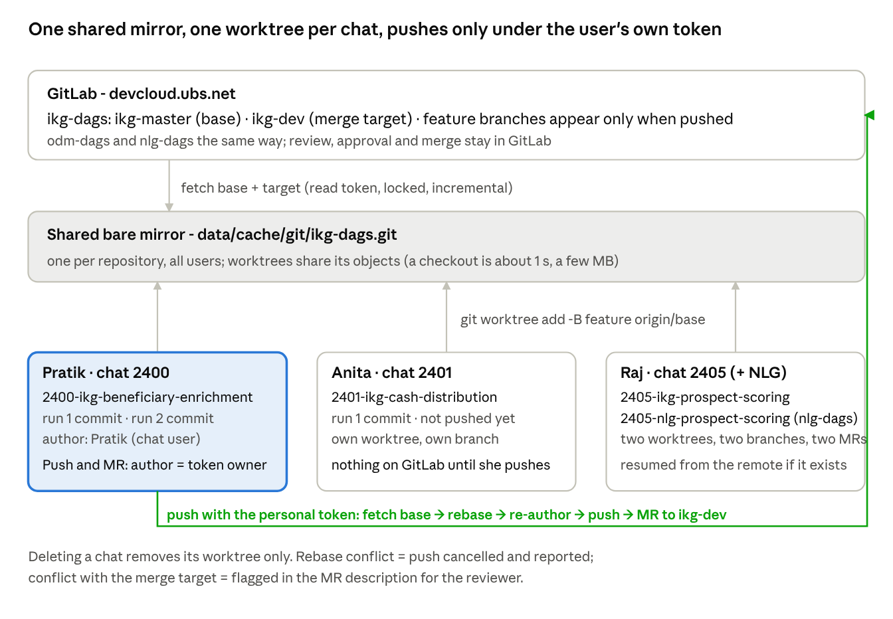
git integration · GitLab, shared mirror, worktrees of three users, push path
Everything below the GitLab box is local to the server; the only path back to GitLab is a push made with the pusher's personal token.

Scenarios

Scenario A - one developer, one story
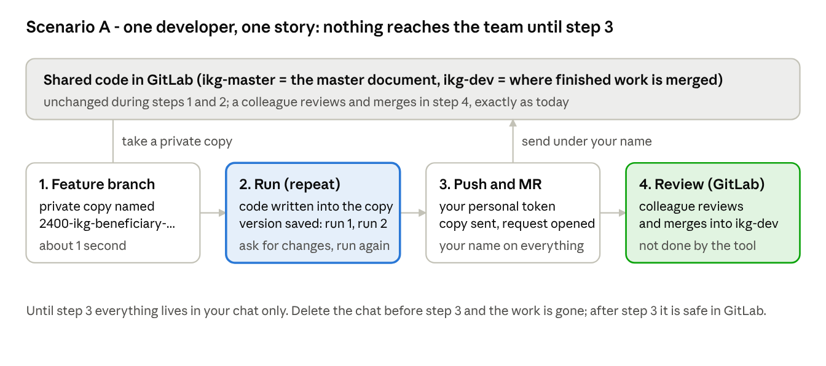
scenario A · one developer, four steps
You work in your own copy for as long as you need; the team sees nothing until you press Push & MR, and then it carries your name.

Scenario B - two developers change the same file
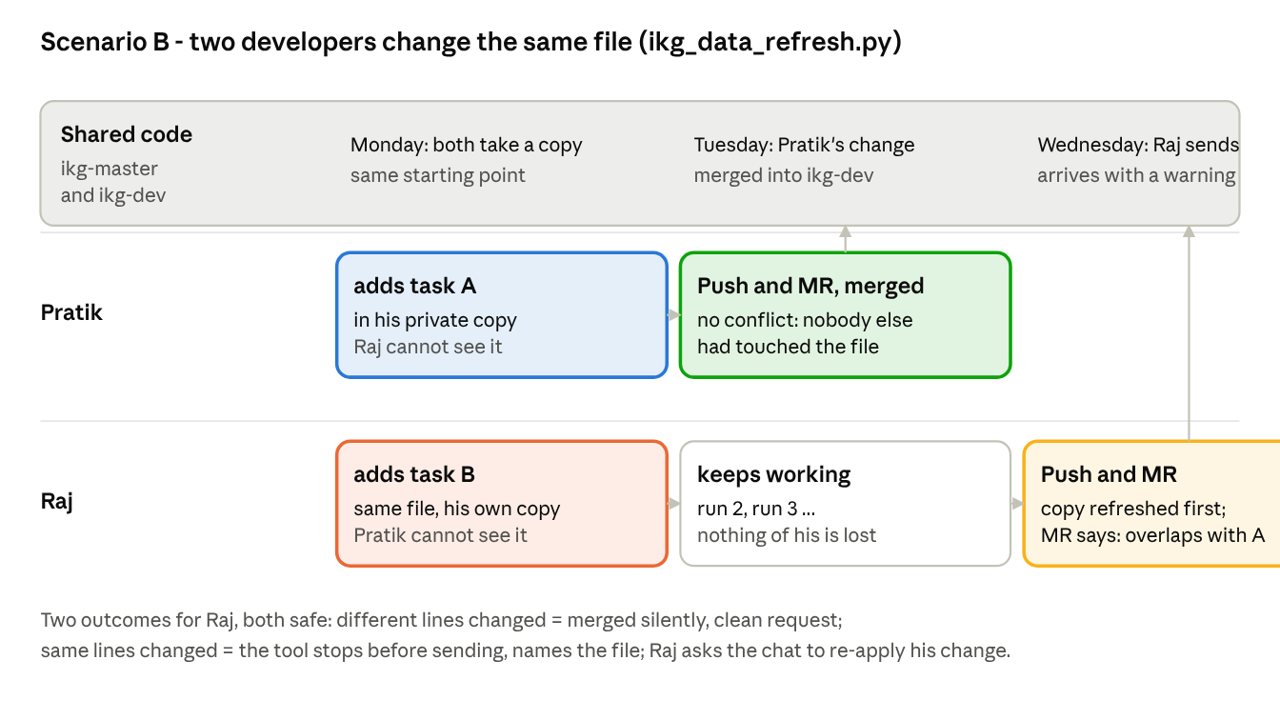
scenario B · two developers, one file
Private copies mean nobody overwrites anybody. The second person to send is told about the overlap before a reviewer ever sees it; the tool never guesses a merge on its own.

Scenario C - one story that touches two systems
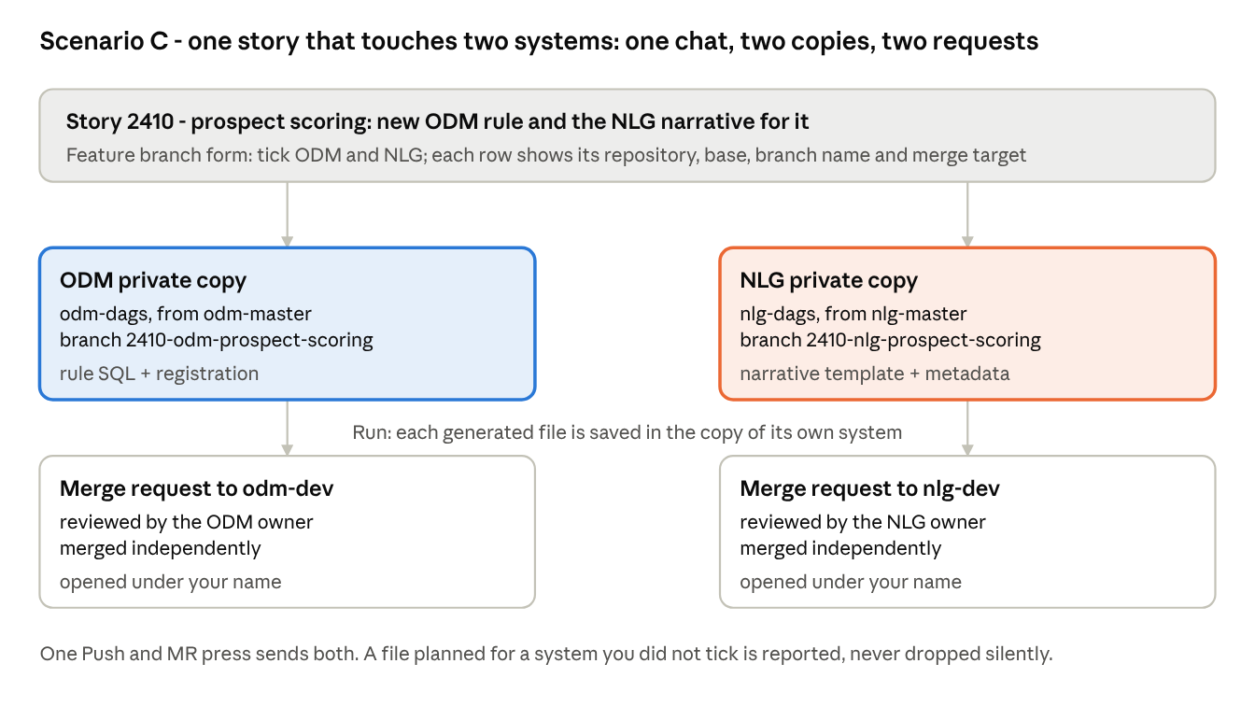
scenario C · one story, two systems
The three systems live in three repositories, so a cross-system story is two private copies and two merge requests, created and sent together from one chat.

All scenarios at a glance
What the tool does for pull, commit and push in each situation. Pull = refresh the private copy from the shared code; commit = save a version in the private copy; push = send to GitLab and open the merge request.
Scenario | Pull (refresh) | Commit (save) | Push (send + MR) | Result
A. One developer, one story | copy taken from ikg-master at checkout; refreshed again right before sending | one version per run, as the chat's user | sent under the personal token; MR to ikg-dev | clean MR, reviewer merges
B. Two developers, same file, different lines | second sender's copy is refreshed; the other change is merged in silently | each in their own copy | both sent; second MR notes the overlap with ikg-dev | both MRs reviewable, no overwrite
B'. Two developers, same lines | refresh finds the clash | versions kept | stopped before sending; file named | developer re-applies via chat, sends again
C. One story, two systems (ODM + NLG) | two copies, one per repository | each file saved in the copy of its system | two pushes, two MRs, one button | each MR reviewed by its system owner
D. Shared code changed while working | refreshed right before sending | unchanged | proceeds if no clash, otherwise stopped | never a stale push
E. Continue an already sent story | branch fetched from GitLab into a new chat | new runs add versions | same branch, same MR updated | one MR per story
F. Chat deleted before sending | - | versions deleted with the chat | nothing was sent | work gone (download zip first)
G. Chat deleted after sending | - | - | - | branch and MR untouched on GitLab
H. No personal token | checkout works with the read token | works | refused | nothing anonymous ever reaches GitLab
I. Chat without a feature branch | - | versions in the chat only | old API push: branch + one commit with the personal token | still supported for quick changes
Other cases in one line each
- The shared code changed while I was working. Before sending, the tool refreshes your copy with the latest shared version. If the same lines were changed by both, it stops and tells you which file; nothing is sent until that is settled.
- I want to continue a story I already sent. Create the branch with the same name in a new chat; the tool picks up your existing copy and merge request.
- I deleted the chat. Your private copy on the server is gone; anything already sent to GitLab stays.
- I have no personal token. You can prepare everything, but Send is refused: the tool never sends code under anyone else's name.

Why this works in every scenario
The tool does not invent its own version control: it runs the same git program developers use, with the same safety rules. Each row is a worry people raise and the rule that answers it.
Worry | What actually happens
Could two people overwrite each other? | No. Everyone works in a private copy; git refuses to let two copies share one branch.
Could the shared code get corrupted by two chats at once? | No. The shared copy is updated one request at a time, and git's own updates are all-or-nothing.
Could a push erase someone's commits on GitLab? | No. A push is refused if the branch on GitLab moved since the tool last looked.
Could stale work be sent? | No. Right before sending, the copy is refreshed with the latest shared code; an overlap stops the send.
Could something be sent half-done? | No. Refresh, re-author, push, merge request happen in that order; any failure stops before the push.
Could a commit or request be anonymous? | No. Every commit is stamped with the owner of the personal token, and the branch and request are created by that same token.
Will a conflict surprise the reviewer? | No. The tool checks the request against the target branch and writes any overlap into the request text.
Can I continue outside the tool? | Yes. It is an ordinary GitLab branch: open it in your IDE, or resume it in a new chat.
Can work be lost? | Only unsent work in a deleted chat. Sent branches and requests are never deleted, overwritten or merged by the tool.
Can a token leak? | No. Tokens are passed to each git command in memory, never written to disk or logs.
Verified end to end against a git remote: checkout, a run that saved a version, a shared-code change in between (refresh clean), re-stamping to the token owner (visible in GitLab's history), push, overlap check against ikg-dev, a conflicting change (send stopped, file named, nothing sent) and cleanup. Two chats on the same repository, with and without a knowledge pack, each saved on its own branch.
Left to people on purpose: review, approval and merge in GitLab; resolving a real conflict; writing to master or dev. GitLab's protected-branch and approval rules stay exactly as they are.

Identity and security
Everything that reaches GitLab carries the name of the person who pressed Push & MR.
Where | Whose name
Versions saved in the chat (run 1, run 2 ...) | the chat's user
Commits on GitLab | the owner of the personal token (every commit is re-stamped before sending)
Branch on GitLab | created by that token at the first send
Merge request | opened by that token; title agile_dev_assist: <story>: <title>; text lists files, confidence, review score and any overlap with the target
Two tokens: the read token (set up once by the admin, or your own) only reads code. Your personal token is typed in the Push & MR form each time; it is kept in memory for that action only and never written anywhere. No personal token, no send.

Instructions for the team
- Set the story first, then press Feature branch. The branch name comes from the story (<story>-<system>-<feature>); keep it.
- Base and target are fixed: from *-master, merged to *-dev. Change them only for a real exception.
- Tick every system the story touches (ODM + NLG = two rows). A file for a system you did not tick cannot be saved.
- Create the branch before the first run. A run before the branch exists is only in the chat.
- Iterate freely. Every run saves a version in your private copy; nothing reaches the team until Push & MR.
- Send with your own token (GitLab personal access token with api and write_repository). It is asked every time and never stored.
- Read the request text. If it mentions an overlap with *-dev (usually ikg_data_refresh.py), resolve it before asking for review.
- "Send stopped - conflict in file X" means someone changed the same lines in the shared code. Nothing is lost: ask the chat to re-apply your change on the current version, then send again.
- Continue, don't duplicate. For review feedback, create the branch with the same name in a new chat; it continues the same request.
- Delete a chat only after sending (or download the zip). Sent work is never touched by the tool.
- Review, approve and merge in GitLab as today. The tool never merges and never writes to master or dev.

Hosting notes
Item | Value / action
Requirements | git 2.38+ on the web-app host; HTTPS to devcloud.ubs.net from it (same route the API already uses)
Mirrors | data/cache/git/<repo>.git, one per repository, shared; storage.git_mirrors_dir in the config
Worktrees | data/users/<user>/chats/<chat>/repos/<repo>/; removed with the chat; git worktree prune runs on each checkout
History depth | git.mirror_depth: 0 = full history of the fetched branches (clean rebases). Set e.g. 200 if the first fetch is too slow; rebases then need the base to be within that depth
Disk | mirror = size of the repository history once; a worktree = the checked-out files only (IKG ~10 MB). 50 active chats on 3 repos stay under 1 GB
Templates | knowledge_packs.templates[*]: repo_url, base_branch, mr_target, branch_template per system prefill the form - check the three repo_url values match the GitLab paths
Locks | one lock per mirror; one job per chat. Expect queueing only when many users check out the same repository within the same second
Logs | every git step is in the chat log (Log tab); token values are masked in error messages
Fallback | without a feature branch the API-commit push (/push) still works unchanged

